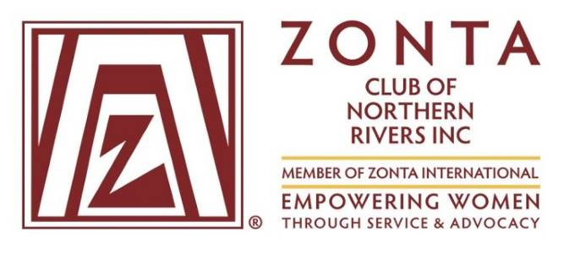
Zonta Club of Northern Rivers Newsletter
July 2021

MEETINGS ARE HELD AT THE ALSTONVILLE BOWLING CLUB @ 6pm Every THIRD Wednesday of the Month
Since our last Newsletter in April we have a new Board for our club. The members of the new Board are as follows:
President: Lyndall Smith
Vice President: Ellen McGirr
Secretary/Treasurer: Julie Burton
Board Members: Lynne Shailer, Anne Flanagan, Lyn Crehan
Welcome to all new Board members and we look forward to working with you in 2021-22.
Introducing our Members
Although we meet monthly, too little time is spent getting to know other club members, so each newsletter will provide some extra information about a couple of our members.
Our new Club President Lyndall Smith has been a member of our club for 15+ years. Lyndall recently retired from teaching where her last position was Head Teacher English at Trinity Catholic College in Lismore. Lyndall is passionate about education and in particular, equity in educational opportunities for women. She is interested in social justice issues and has been a leading voice at our club regarding our current local project – Older Women’s Homelessness.



Lyndall loves to travel and spend time with her children and grandchildren in Sydney and Brisbane.

Her other interests include poetry and drama, swimming, walking on the beach and catching up with friends.

Stephanie Hunt is one of our newer members. Stephanie has called the Northern Rivers home for almost 25 years, moving here from Kakadu National Park with her husband and young family. She has a lifelong love of writing and learning, gaining qualifications in Secondary and Adult Education and Science.

Stephanie has over 30 years’ experience in many forms of writing – instructional design, scientific papers, editing and proof-reading, reports, and newspaper articles - and has recently launched her own small business, Write on Copy and More. She is also a regular contributor to our local Country & Coast Lifestyle Magazine.
Stephanie is greatly interested in ensuring that all women have the best educational opportunities possible, to ensure they have the skills, knowledge and confidence to secure their futures. This includes work, business, health and financial education.
She has volunteered to manage our club’s social media pages, but is always grateful for any ideas, input and photos from Zonta NR members.
We are delighted to have Stephanie join our club this year.
Club Projects and Activities
Older Women's Homelessness and Housing Issues : Zonta D22 Advocacy Campaign
We are all looking forward to meeting and hearing from Jenni Beetson-Mortimer from Northern Rivers Community Gateway at our JULY Zonta Meeting. Jenni will talk about the NRCG project for Older Homeless Women in our region and we are all eager to listen and learn how we could assist.

25th Anniversary of Zonta Northern Rivers December 2021
This year, 2021, is the 25th birthday of the Zonta Northern Rivers Club. Planning is well underway for a special function to be held later in the year to mark this special occasion. At this stage a tentative date of 5 December 2021 has been set. We hope to invite as many past members of the club as we can locate so we would appreciate any contact details for past members to be provided to those collating this information (at present Lyndall and Anne).

Special thanks to Rosalie who has upskilled our club by completing the Bunnings Covid Captain training. This will enable us to accept future fund raising opportunities through the Bunnungs Sausage Sizzle program.

What is happening in other parts of the World?
Samone provided some excellent information including a video clip at our June meeting of a Zonta project in some African countries (Ethiopia and Sierra Leone) to prevent child marriage. This highlighted how important it is that our local club donates to such International Projects as the continuation of this project is so important for the young girls in these countries. It is perhaps worth repeating that Zonta International has improved women’s health, provided better educational opportunities and prevented gender-based violence in 66 countries.
In Peru Zonta International’s partnership with UNICEF is aimed at improving the capacity of services to respond to the health needs of adolescents in two specific regions in Peru. The following is an extract from the ZI website regarding the project:
Adolescents, especially girls, must be given opportunities to empower themselves and develop the self-confidence and autonomy needed to take control of their lives and bodies, and to speak up for their rights. Significant inequities based on gender, age, geographical location, ethnicity and income persist for many Peruvian adolescents. Being an adolescent girl, indigenous and living in a rural area, makes these inequities even more significant.
Zonta International’s partnership with UNICEF USA’s Adolescent Health and Protection project in Ucayali and Huancavelica—regions of Peru—aims to improve the capacity of services to respond to the health needs of adolescents in a timely manner and prevent all kinds of violence in schools.

Diary Dates for 2021
January 20 - Monthly Meeting Alstonville Bowls Club 6pm
February17 - Monthly Meeting Alstonville Bowls Club 6pm
March 17- Monthly Meeting Alstonville Bowls Club 6pm
April 21- Monthly Meeting Alstonville Bowls Club 6pm
May 19- Monthly Meeting Alstonville Bowls Club 6pm
June 16- Monthly Meeting Alstonville Bowls Club 6pm
July 21- Monthly Meeting Alstonville Bowls Club 6pm
August 18 – Monthly Meeting Alstonville Bowls Club 6pm
September 15 AND possibly –D 22 Conference & Area 2and 3 Meeting - TBA
October 20- Monthly Meeting Alstonville Bowls Club 6pm
November 17- Monthly Meeting Alstonville Bowls Club 6pm
December 5 25th Anniversary Brunch
December15 - Christmas Dinner Meeting

