

The Metro

Zonta Brisbane Metro Breakfast Club Inc.

Issue 19
July 6 2005

Welcome

Congratulations to Leanne Linard who is our Club winner for the Jane M Klausman award. Leanne will be presented at our Breakfast meeting with her $250 cheque. Leanne’s application has been forwarded to the District. We wish Leanne every success at this level. We look forward to Leanne informing us of her studies and her aspirations.
to our newest member Liz Clewes and to guest Virginia Pearson. Virginia has supported our Club by seeking nominations from QUT for the Jane M Klausman Award. Welcome to Janice Cain as a visiting guest to our Breakfast meeting.

Our Club Fund raising activity for July

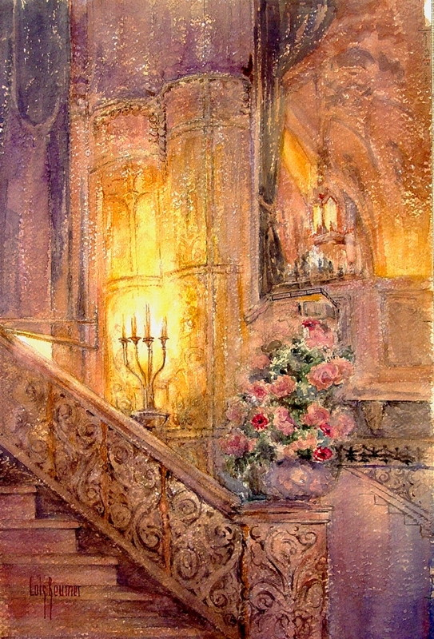

7 July - Red Hill Art Gallery
61 Musgrave Road, Red Hill
Presents
Lois Beumer Watercolours

Will you buy the lucky raffle ticket on the night?

Raffle

1st prize – Artist’s etching

2nd prize – Book – Good girls don’t want the Corner office

3rd prize – a year’s subscription to “Queensland Property Lifestyle”.

Tickets $5 each or 3 for $10 – ticket sellers will mingle with guests

Please remember to bring the money and number of the guests you have successfully invited for the Red Hill Art Gallery Fund Raising activity and give these to Cath Cosser.

A great night’s value - Champgne and nibbles supplied by Rosalie Gourmet Markets Deli and entertainment by an eight Voice choir as well as the chance to view an artist’s works for only $20!

Our condolences to Rita, whose lovely sister, Trish, passed away on 24 June. Our thoughts are with you Rita at this time.

Board members for 2005/6

President - Celeste Neander Committee Chairs
Vice President – Elaine Harrington Status of Women & Service/UN – Cath Cosser
Treasurer – Rita Logan Organisation, Membership & Classification – Correspondence Secretary – Kate Farrell Amena Reza
Minutes Secretary - Terry Creagh Public Relations – Elaine Harrington
Directors – Cath Cosser, Amena Reza, Jan Mohr

District 24 Club No: 1624
Area 5: DIRECTOR: Vicki Varthas GOVERNOR: Ros Kinder Website. www.zontadistrict24.org

Member profile
Getting to know Michelle Wells…..

Having read the fascinating member profiles in The Metro over the last couple of months, I realise I have a hard act to follow, but I shall try to give you a little insight to my history thus far.

I grew up in Brisbane as the youngest child of four, and as such was very fortunate to learn enough from my elder siblings to keep me out of trouble. One of my favourite past times is reading - to which I have devoted many hours from a very early age - either alone or out loud in front of an audience. In my younger years, it seems my preference was towards the latter and having once mastered the art, I used to follow my family around the house reading to anyone (or anything) I thought would listen. My mother in her wisdom decided I needed an outlet for this new found talent and enrolled me speech and drama lessons, which very quickly became one of the great passions of my life.

For almost 15 years I attended weekly lessons with the same teacher and ended up becoming one of her longest standing pupils! During this time I undertook a number of exams in speech and drama through the Australian Acadamy of Music (AMEB) and completed a teaching diploma in speech and drama through Trinity College in London. While I had always entertained many childhood dreams for a career on the stage, it was during one of these exams that I was presented an alternative choice by the examiner, who also happened to be a lecturer in communication at QUT. A couple of years later, having decided the acting world would be too hard a nut to crack, I was to take her advice and in 1997 completed a Bachelor of Business in communication and public relations at QUT. With the hope of combining this new knowledge with my verbal communication skills, I found myself a job as a marketing and public relations officer for the Department of Public Works, and have been working in the corporate communication field ever since.

In 2001 I joined the many thousands of Australians heading overseas and moved to London with my then boyfriend, who was later to become my fiance during a romantic weekend away in Prague. Despite the homesickness, and those gloomy winter months, I had a fabulous time there and worked as a media officer for the Commission for Health Improvement, otherwise known as the watchdog of the English healthcare system. Having come from a home town where The Courier-Mail is the only metropolitan newspaper, I was initially blown away by the enormity of the UK media industry, but eventually I got used to dealing with its 10 daily newspapers and myriad of television and radio journalists. In July 2004, after living like professional tourists for almost three years, we decided it was time to head home, get married and embark on another exciting period in our lives.

I was first introduced to Zonta in 1995 when my mother, Diane Harmsworth, joined the Wynnum Redlands club. In fact, while studying a subject in publicity methods at uni, I wrote some of my first press releases for the club’s PR committee and was thrilled to see them appear in the local paper. At the beginning of this year, having seen how much mum had enjoyed her years with Zonta and how much she had personally gained from it, I asked her to suggest a club and she didn’t hesitate in recommending this one. I am truly delighted to have been accepted as a member of your club and look forward to many enjoyable times ahead of working with you and getting to know you all.

Michelle
(Michelle is also the new editor of our monthly newsletter – The Metro . Congratulations and thanks to Michelle for taking on this task to support the Club.)

Special congratulations to Jan who celebrates her 50th Birthday on 25 July and to
Elaine who celebrates her birthday at our breakfast meeting on 6 July

Anglican Women’s Hostel

Donation for July

Please bring canned food,
packets of pasta,
rice, tea, coffee.


Do you have a colleague or friend New Member Information Evening interested in joining our 16 July @ ML Design Zonta Breakfast Club? Bring her to our 200 Mary Street

Committee Reports
Public Relations
The first meeting of the new committee was held recently.
PR details for the Red Hill Art Gallery fund raising function were finalised. Michelle also wrote a media release to be used leading up to the function. This includes the publicity of our Club through photos and board display.
Michelle has also indicated her interest in taking on the monthly Newsletter.
PR Committee will be responsible for the organisation of the Trash & Treasure along with the support of all members of the Club.

Status of Women and Service
This committee has been working hard to ensure a successful fund raising night at the Red Hill Art Gallery next Thursday 7 July – see front page for details.
Sally continues to provide monthly updates to the club on International issues. This is appreciated by all.
The Anniversary Function is being organised for 23 July. Invitations will be coming to members, partners and HonZons shortly.
The Breast Cushion project continues to be appreciated by recipients with quite a few thank you letters being received in recent months.
A film evening is being organised for 29 September to see the film “Brides”.
Footprints of Service now has a new format – Cath will pass this on to Committee Chairs at the Breakfast meeting.

This Month – UN Update

Sally will provide us with information on World Population Day on 11 July and on Diabetes

Membership and Organisation
The Committee structure for the club for this year has been finalised. All members now should be aware of their Committee.
At the recent meeting, there was discussion about a buddy system and perhaps implementing this in a more systemic way to support new members.
All members records are being updated.
Members discussed the organisation of a fund raising or even a social/fellowship function later in the year – either in the line of a Bar Soma event or perhaps tagging on to a larger event where our club may be able to support and benefit.

Some good sellers are:
- crockery and cutlery, designer and other clothes, accessories, household goods including the kitchen sink, children’s toys and bicycles, books, magazines and old records, plants
Have you started to collect from your friends the goodies for our
Trash and Treasure

20 August

Where?
Grounds of Absoe Pty Ltd
Boundary Street , West End.

See Elaine for further information

Please ensure that all goods for the Trash and Treasure are clean, not broken, and are priced. See Celeste, Kate or Elaine about pricing.

The following “tale” is from our intrepid, nearly 50 year traveller and member

Good Morning Vietnam…
I have just spent 2 weeks holidaying in Vietnam and Cambodia and thought I would share a few highlights.

Motorbikes are absolutely the mode of transport in Vietnam – masses of them flowing through the streets of Saigon and Hanoi, with barely a car to be seen. And they are often carrying a family of 4, one child between the driver and the handlebars, the other child sandwiched between the driver and the other adult passenger.

The Vietnamese are very friendly, optimistic people, mostly putting the war behind them. I was travelling as part of a small group tour and we had a series of local Vietnamese guides, all of whom had real pride in their country.

The French influence was quite pronounced in some places, particularly in Hanoi, a very likeable city and easy to pass the time wandering around the Old Quarter, or better still winding around the streets on a cyclo (someone else doing the peddling!).

Regional Vietnam has many interesting and picturesque towns, Hoi An a particular favourite. Hoi An is a small but historic town, plenty to see, lots of shopping opportunities and plenty of tailors, turning around suits, dresses, whatever you want, in less than 24 hours. The countryside is typically rice paddy fields, using water buffalos rather than tractors.

Cambodia was quite different, lacking basic infrastructure and much poverty. Unlike Vietnam, where family planning is mandated, typically the Cambodian family sizes is large and for many, it is a struggle to put food on the table, with many beggars and land mine victims in the major towns and the cities. Phnom Penh was my least favourite place, but necessary to appreciate the incredibly difficult history of Cambodia.

But aside from these harsh realities, the temples of Angkor are amazing. The scale is hard to comprehend, as they cover the same area as the city of Los Angeles. There are numerous temples to see, all quite different, with statues, bas-reliefs, and a place to really step back in time.

Both countries were shopping and eating heaven (but wine was prohibitively expensive). For shopping, there are so many markets selling fake anything, handicrafts, silk, handbags and bargaining is the name of the game, even though prices are cheap to begin with. There is an abundance of fresh fruit and we ate beautiful, healthy meals, very cheaply.

This is definitely a destination to add to your holiday wish list!
Dairy Dates

7 July - Red Hill Art Gallery – presenting Watercolours by Lois Beumer
14 July – New members Information Evening @ ML Design
16 July – Villa Maria visit and morning tea
20 July – Dinner with Zonta International POresident, Mary Ellen Bittner at the Parliamentary Annexe, Alice Street, Brisbane
24 July – Quilts for a Cause – An Expo of Quilts - 10am – 4pm Glennie School, Herries St, Toowoomba, $10 Admission
27 July - Anniversary Celebration –Brilliant Facets, 127 Margaret Street
20 August – Trash and Treasure
28 August – Great Zonta Car Rally – SGC Tweed Zonta
29 September – Movie Night - Brides

