ZONTA CLUB OF MOUNT ISA Inc Newsletter

P O BOX 2442, MOUNT ISA QLD 4825

President: Michele Savoye PH 0417 737 090 N/Letter Editor: Liz Ryan
Vice President: Carolyn Hay Any submissions to N/Letter email to Liz Ryan - MIPP@bigpond.net.au
JUNE 2005

Ex-President’s Patter

Hello Ladies,
Just a quick gossip to keep you all in the loop till Michele gets back.

We have lost another great Zontian. Alice Clarke has resigned from the Club. She’s sooo busy, and apparently is intending to do more great and wonderful things. We wish her well, but I for one will miss her! See ya Alice!

AREA 7 WORKSHOP !
Well here we are, a couple of photos of Area 7 Workshop. I said they’d be in this newsletter, and here I am delivering.
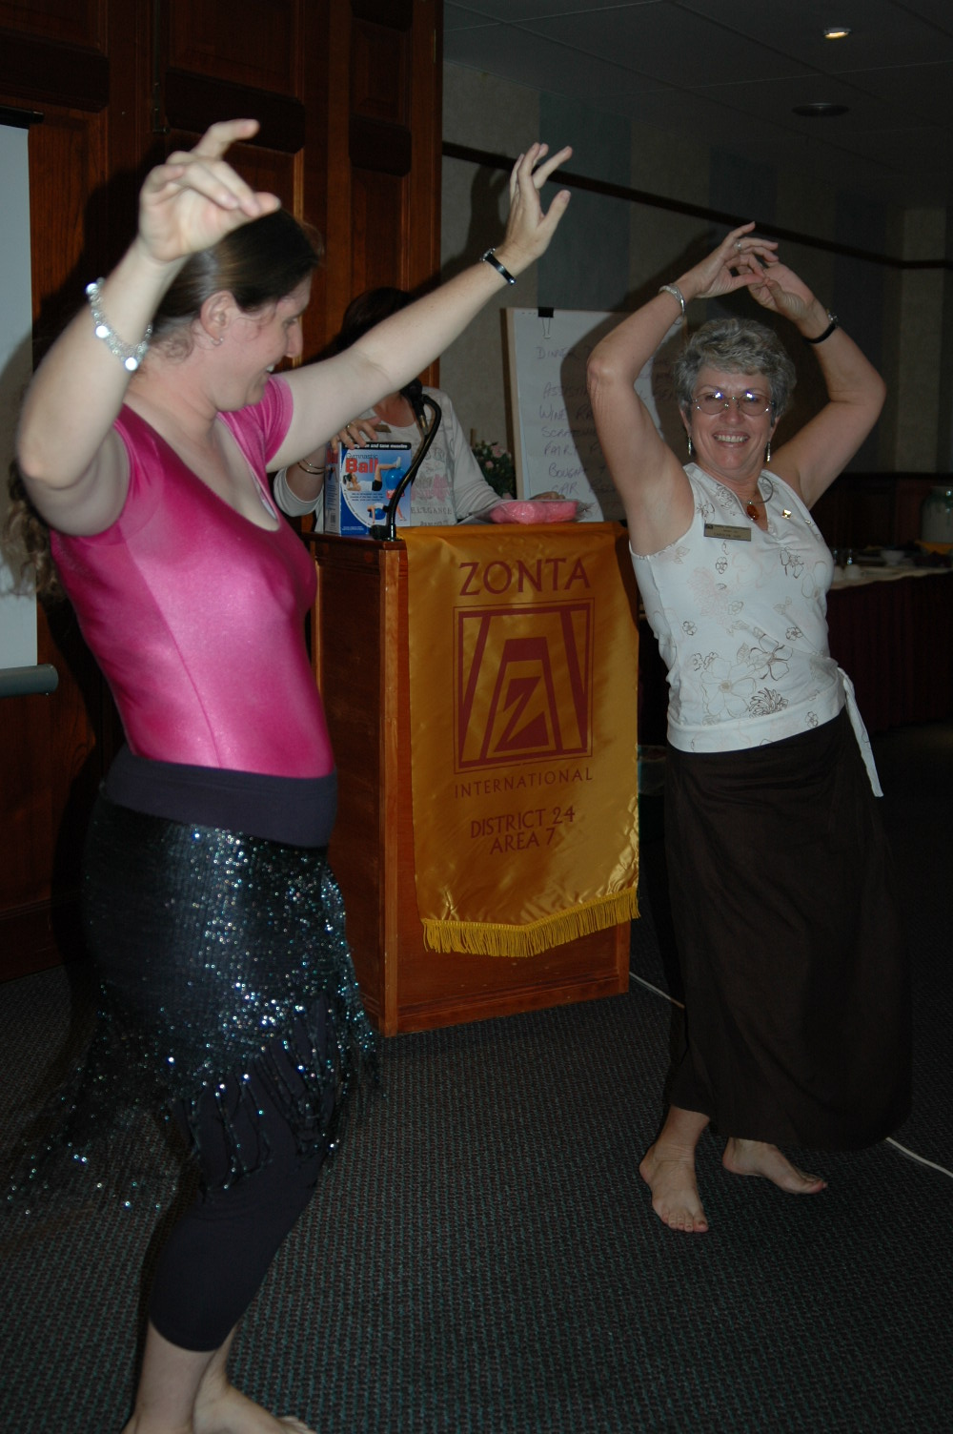
Carolyn getting some handy tips from our Belly Dancing Instructor. (Carolyn went on to win the competition that night!)
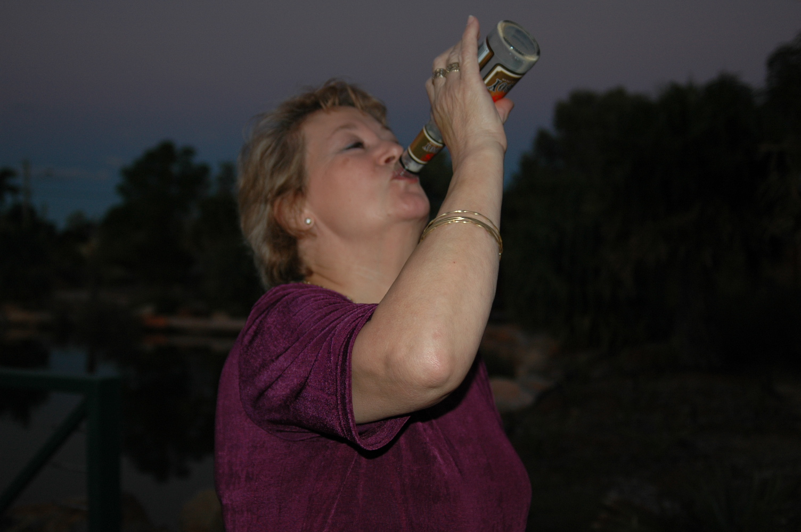
Vera enjoying a tipple on the Bus Tour (Note little finger in the air!)

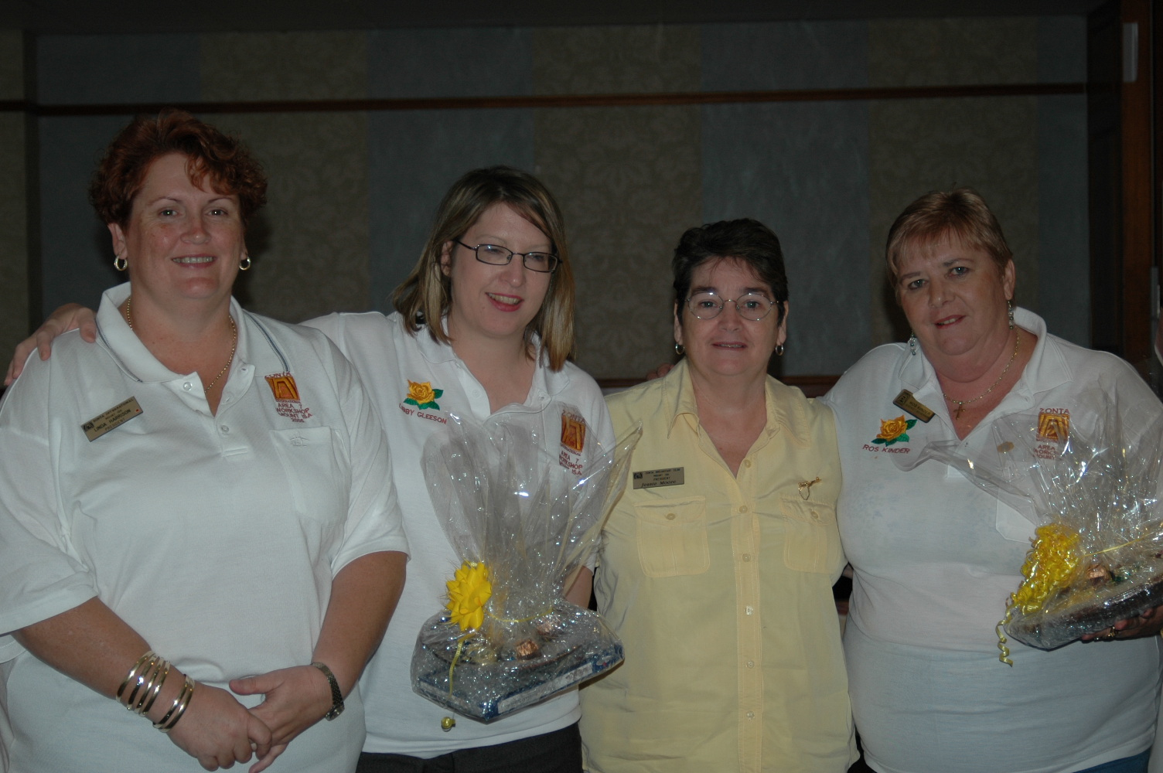
The President’s of the Mt Isa Clubs with DG Ros and Area Director Libby.
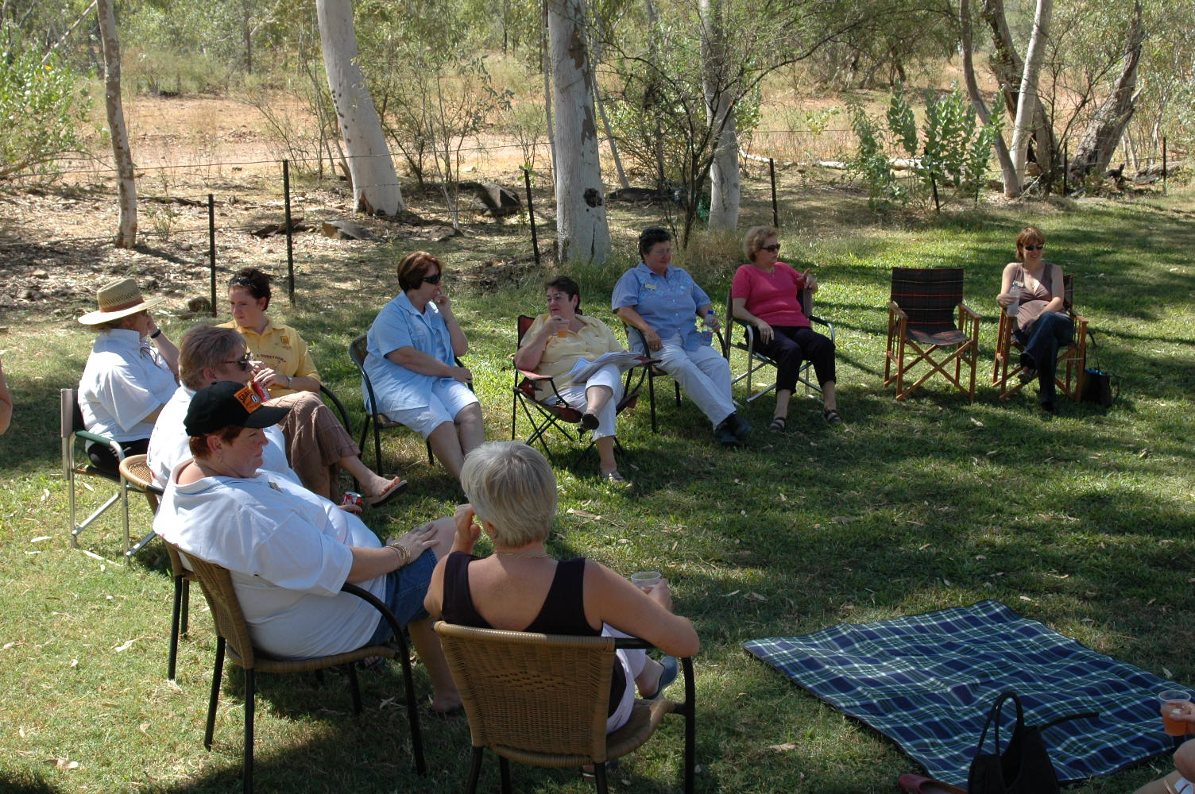
Lunch out at the lake on the Sunday. Everyone relaxing and enjoying themselves.

JUNE MEETING – 15TH JUNE
Well, ladies, our June meeting is on the same night as the 2nd State of Origin Game.

With this in mind, we will be having a Coffee and Cake night at Terrace Gardens. However, start time has been changed.

Time is 6pm for a 6.15pm start. Cost is $15-00. Sonja has promised to turn on a great feed with nibbles and sweets. Bar is open, so we can lubricate our vocal cords for the necessary slurs against the Umpire, the opposing team etc when you get home.
Theme for the night is State of Origin, so wear your team colours. Maroon is a must, if you’re game, please feel free to wear blue too. You will get heckled by we cane toads though!

Well, we’re in hold the pattern mode. So, not much gossip this month. Michele will be back next month to feed you lots of info.

See you at the June Meeting
To Rhonda Pengo,

Our thoughts and prayers are with you, if there is anything you need just ask.
Love your Zonta Family.
XXX

ZONTA ON!!
Linda Harrison
EX-El Presidente.

OUR BIRTHDAY GIRLS
FOR THIS MONTH ARE!

VERA GRIMALDI 8th June
JODIE MULLEN 10th June
LEONIE MOORE 14th June

AGM
We hope to open AGM to accept Treasurer’s Report – and then close again. This should happen at next meeting!

Next Meeting
Wednesday, 15th June
Terrace Gardens
6pm

THOUGHT FOR THE MONTH!

At any moment I could start being a better person.
Which moment shall I choose.

