‘THE WHISPER’
Official Newsletter of Bowen Zonta Club Inc.
District 24 Area 7 Club 1476 July 2005

WHAT’S HAPPENING

Tonight’s Meeting

Handover dinner 13 July – social night, please plan to bring partners.
$20 per head. Numbers to Angela by 12 July.
Slate of candidates on back page.

NEXT MEETING

Wednesday 10th August
7pm Castle Motor Lodge

Apologies to
Angela Cornwell
4786 1496 (h)
4785 1255 (W)

Remember if no apology received, full payment for dinner is owed to the club.

CONTACTS

President
Laraine Smith
4785 1230
lfsmith0@tpg.com.au

Treasurer
Bon Wharley

Secretary
Angela Cornwell
4786 1496 (h)
4785 1255 (W)

 From the desk of the Editor
Any items of interest you wish published, write to the editor or email your info, we want an entertaining and informative newsletter.
The Editor
Bowen Zonta Club Newsletter
PO Box 1023
BOWEN QLD 4805
Email: dympian.lee@bigpond.com
Committee Reports
PRESIDENT’S REPORT:

MEMBERSHIP:

STATUS OF WOMEN
A meeting will held with the new committee members some time after the Handover Dinner.

Rhonda

PROGRAM

COMMUNICATIONS
Zonta Bowen’s website is still under construction. Linda will contact the “Bowen Guide” coordinators and ensure the Club’s contact details are current.

FUNDRAISING

Ben Deluca has the club’s booking for a Movie Premiere and will notify the Club when a suitable movie is available. The 100 Club will be delayed until 2006.
Grapevine
Rhonda asked members to sponsor her in the Townsville to Cairns Bike Ride for the Children’s Cancer Fund. $114 was collected.

Have you registered yet for the 2005 District 24 Conference at the Crowne Plaza, Surfers’ Paradise?

Maybe Bowen might like to think about nominating for the following awards?
Nominations close in September.

Club Recognition Awards Continued

Organisation, Membership & Classification

Membership Growth
These awards will be based on the highest percentage membership increase according to the size of the Club ie for Clubs <20 members, Clubs with 21-40 and Clubs with >40 members

Membership Retention
These awards will be based on Club size as above ie <20 members, 21-40 members and >40 members and will recognise Clubs with the best retention rate (fewest resignations as a percentage of membership during the Club year).

Size of Club will be taken as reported and paid to the District as at 30/06/2004 compared to 30/06/2005 with retention calculated on resignations as reported to the District with payment of dues as at 30/06/2005

PROFILE

Profile – Hortense Ingram

During the mid 50’s and 60’s I grew up in Windsor Ontario, across the river from the motor city of Detroit in the US. Essex County, the most southern part of Canada is famous for its Windsor Salt, Canadian Club whiskey, tomato capital of Canada, juicy corn on the cob and nature parks along the Great Lakes. In the summer when I wasn’t camping and boating, I picked tomatoes and cucumbers and de-tasselled corn for a hybrid seed company. During my youth I travelled overseas to romantic Europe, the beautiful Greek islands, Moslem countries of the Middle East and fascinating India.

Upon returning to Canada, I pursued university education in Ontario and Montreal Quebec. I was offered a teaching position in a country school, specialising in physical and health education. For 10 years I lived in Goderich, population 7,000, located in the snow belt on Lake Huron. Snow drifts as high as the school bus were not uncommon! With a year’s leave of absence I was off to the warmer climates of Hawaii, New Zealand, Australia, Asia, India and Europe again. In Australia I drove from Sydney across the Nullarbor to Perth in a white Cortina, camping in national parks.

Back in the snow country I would often dream about snorkelling and swimming in clear blue warm waters. During this time I undertook a teacher exchange in Perth. Rather than endure the ice and snow, I jumped at the chance of being sponsored in the computer industry as a trainer. For the next 10 years I was involved with training, sales and marketing of business solutions in Perth. Here I met my husband and raised 2 children who were very active in sports.

Following a retrenchment in the computer industry, I pursued a career in both lecturing and management with a TAFE college. Several times my husband and I chartered a yacht to cruise the Whitsundays. As we loved the islands and the lifestyle, we left Perth after 20 years, drove across Australia with our dog and my mother in law in the back seat and moved to Bowen, never having seen the town!

After a successful career and life as a mother, I am now semi retired, enjoying other interests. I believe there is no greater virtue than being of service to others, beginning with your own family and local community. I am an active community member with the Healthier Bowen Shire Partnership and the North Queensland Cruising Yacht Club. I hope I can make a difference to those who are not as fortunate, particularly women and our youth.

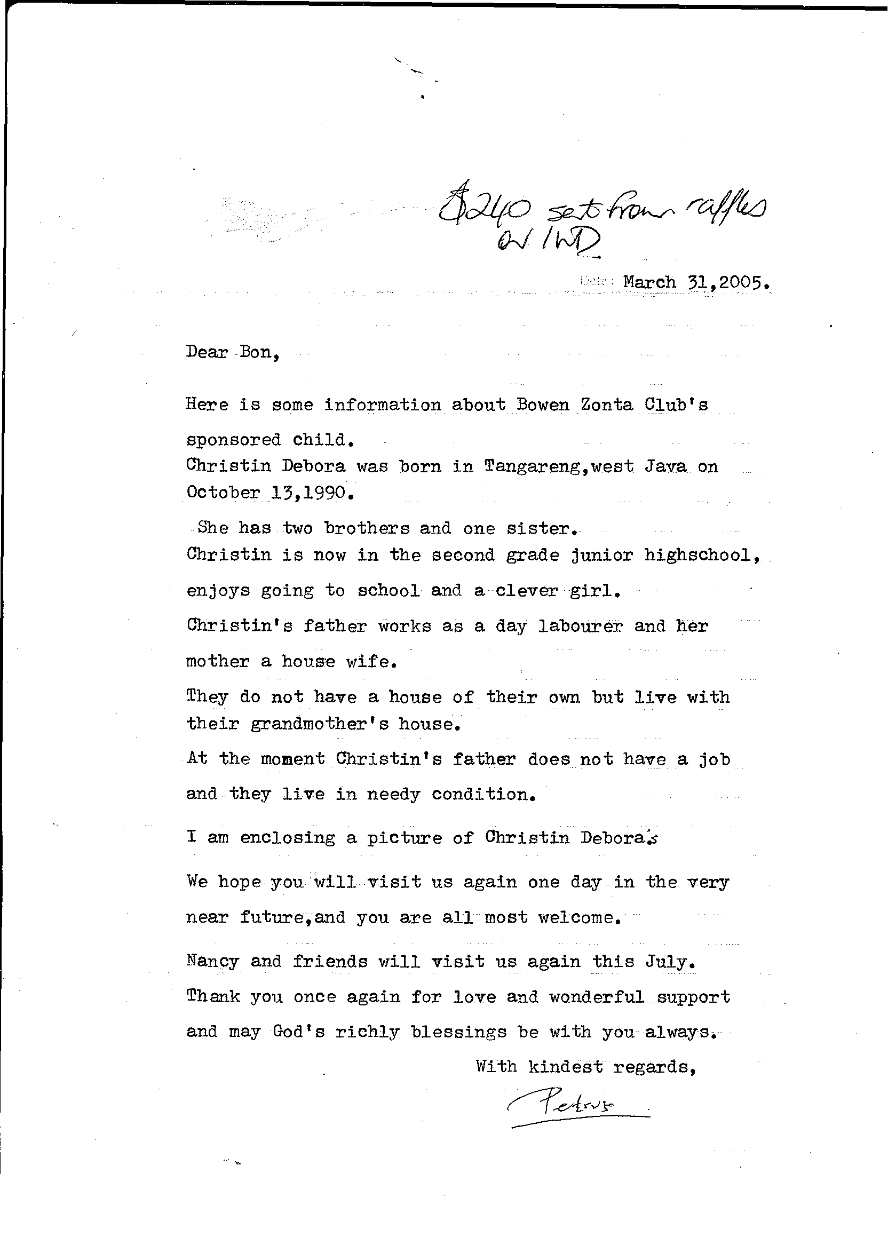
2005 sponsor a child letter

‘was unable to scan photo enclosed – will have it with me at the meeting.’

ZONTA CLUB OF BOWEN Inc.

SLATE OF CANDIDATES 2005/2006
POSITION | NAME | COMMITTEE MEMBERS
President | Laraine Smith
Vice President | Karole Bayldon
Secretary | Angela Cornwell
Treasurer | Bon Wharley
Finance & Fundraising (Chairpersons) | Jan Pearce & Lyn Allison | J Jurgens; L Smith; L Cunningham; M James; T Mayhew; L Tickle;  C Barrett
Membership (Chairperson) | Lynette Klukas | L Allison
Program (Chairperson) | Cheryl Vennard | B Wharley; K Bayldon
Status of Women (Chairperson) | Rhonda Nilsson | V Hickmott; J Pearce; A Cornwell; T Mayhew
PR & communications | Linda Tickle
United Nations & Advocacy | Von Hickmott
Newsletter | Rhonda Nilsson
Attendance | Therese Mayhew
Raffles | Malda James
Archives | Julie Jurgens
Directors | - J Jurgens  - V Hickmott  - M James

DON’T FORGET BOARD MTG HIGH SCHOOL
WED 3rd August 5pm
The views expressed in this newsletter are not necessarily those of Zonta International

